WEEK-7

React JS HOL-11

**• Explain React events**

React events are actions that can be handled using React’s system, such as clicks, form submissions, or mouse movements. These events work similarly to DOM events but are wrapped in a React-friendly way for better cross-browser support.

**• Explain about event handlers**

Event handlers are functions that are triggered when a specific event occurs. In React, you attach an event handler using JSX syntax.

Example:

<button onClick={handleClick}>Click me</button>

Here, handleClick is the function that runs when the button is clicked.

**• Define Synthetic event**

A synthetic event is a React wrapper around the native browser event. It is part of React’s cross-browser event system and behaves identically across different browsers, ensuring consistency.

**• Identify React event naming convention**

In React, event names use camelCase instead of lowercase. For example, the HTML onclick becomes onClick in React, and onchange becomes onChange.

**App.js**

import React, { useState } from 'react';

import './App.css';

import CurrencyConvertor from './CurrencyConvertor';

function App() {

  const [count, setCount] = useState(0);

  const increment = () => {

    setCount(count + 1);

    sayHello();

  };

  const decrement = () => {

    setCount(count - 1);

  };

  const sayHello = () => {

    alert("Hello! This is a static message after increment.");

  };

  const sayWelcome = (message) => {

    alert(`Message: ${message}`);

  };

  const handleClick = () => {

    alert("I was clicked");

  };

  return (

    <div style={{ margin: '20px' }}>

      <p>{count}</p>

      <button onClick={increment}>Increment</button><br></br>

      <button onClick={decrement}>Decrement</button><br></br>

      <button onClick={() => sayWelcome("Welcome to the app!")}>Say welcome</button><br></br>

      <button onClick={handleClick}>Click on me</button>

      <br /><br />

      <CurrencyConvertor />

    </div>

  );

}

export default App;

**CurrencyConvertor.js**

import React, { useState } from 'react';

function CurrencyConvertor() {

  const [rupees, setRupees] = useState('');

  const [currency, setCurrency] = useState('Euro');

  const handleSubmit = (e) => {

    e.preventDefault();

    if (currency === "Euro") {

      const euroAmount = parseFloat(rupees) * 80;

      alert(`Converting to Euro Amount is ${euroAmount}`);

    } else {

      alert("Unknown currency selected.");

    }

  };

  return (

    <div>

      <h1 style={{ color: "green" }}>Currency Convertor!!!</h1>

      <form onSubmit={handleSubmit}>

        <label>

          Amount:

          <input

            type="text"

            value={rupees}

            onChange={(e) => setRupees(e.target.value)}

          />

        </label>

        <br /><br />

        <label>

          Currency:

          <select value={currency} onChange={(e) => setCurrency(e.target.value)}>

            <option value="Euro">Euro</option>

          </select>

        </label>

        <br /><br />

        <button type="submit">Submit</button>

      </form>

    </div>

  );

}

export default CurrencyConvertor;

**Output:**

**Message after clicking Increment**

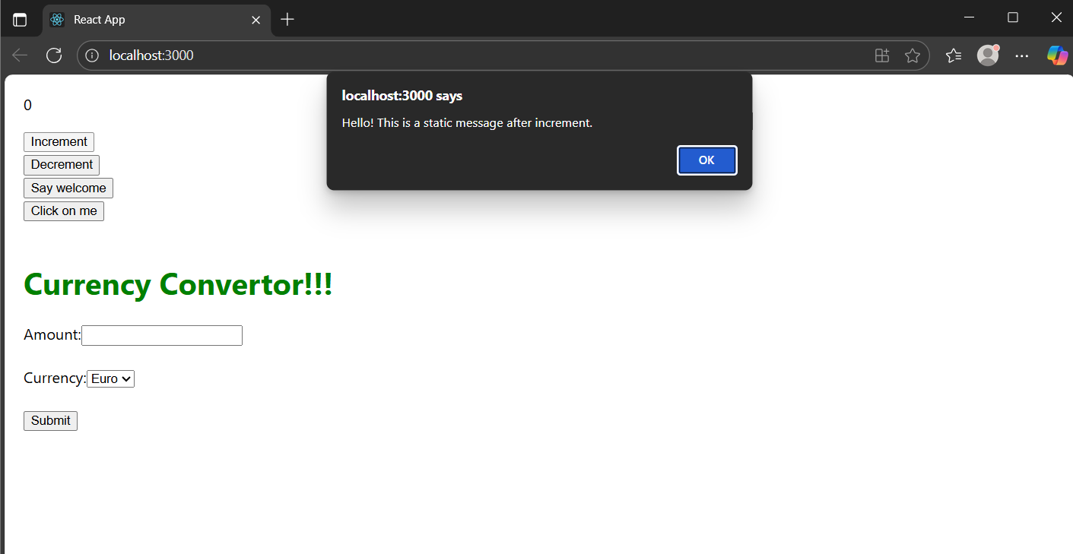

**Welcome message**

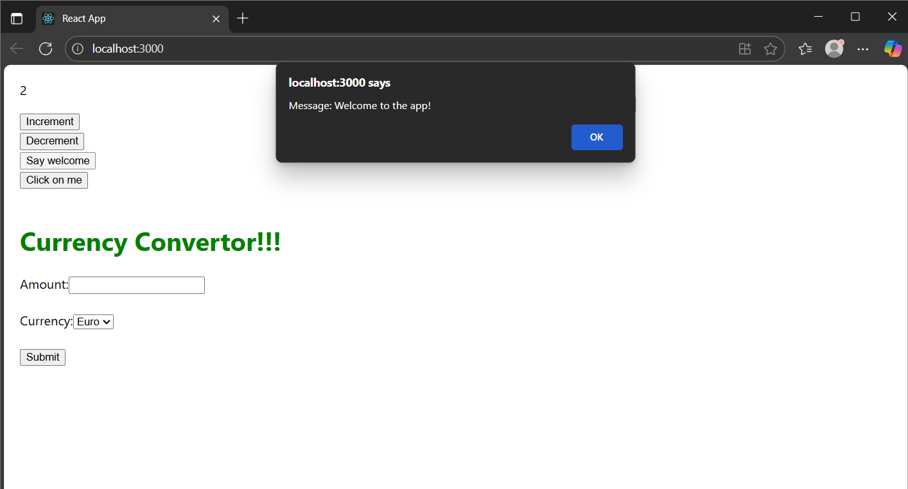

**Click button**

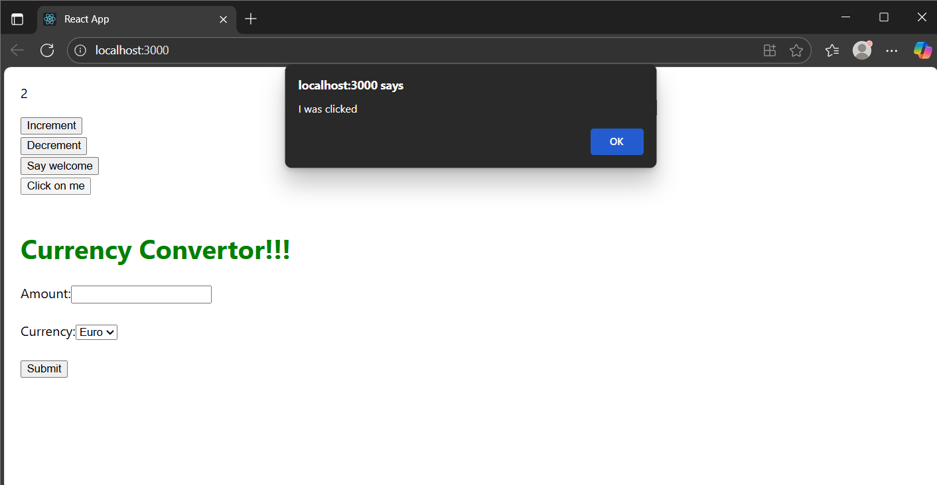

**Currency convertor**

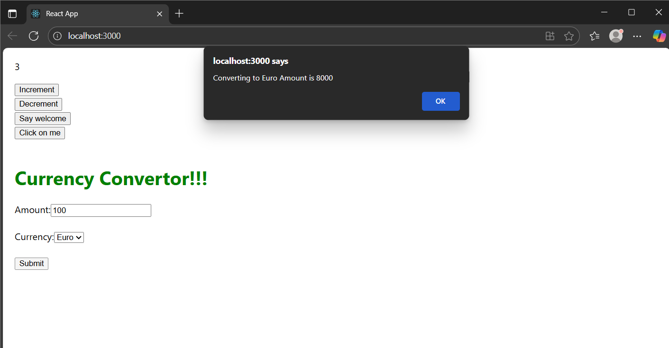

**Explanation:**

* Handled Button Click Events  
  I created buttons like Increment, Decrement, Say Welcome, and Click on me, each performing specific actions when clicked using React event handlers.
* Used Multiple Functions on One Event  
  On clicking the Increment button, i increased the count and also displayed a greeting using two separate functions triggered together.
* Passed Arguments to Functions  
  I used the Say Welcome button to call a function and passed a custom message ("Welcome to the app!") to be shown in an alert box.
* Demonstrated Synthetic Events in React  
  The Click on me button showed how React handles browser events using its own system called "Synthetic Events" for better performance and compatibility.
* Built a Currency Converter Form  
  I created a CurrencyConvertor component with input fields and a dropdown. When submitted, it converted the Indian Rupee amount to Euro and showed the result in an alert box.